HOW TO DETECT NOVA CLIENT

In this Guide i will go over every way to detect Nova Client (discord.gg/novaclient) fully skidded of argon client made by lvstrng (https://github.com/LvStrnggg/argon)
Step 1. detecting replacement/deletion:
So as many client have this feature it will be useful for other clients as example grim client. Go on downloading either Journal-Trace (https://github.com/ponei/JournalTrace/releases/download/1.0/JournalTrace.exe) or EchoJournalTool (https://dl.echo.ac/tool/journal).

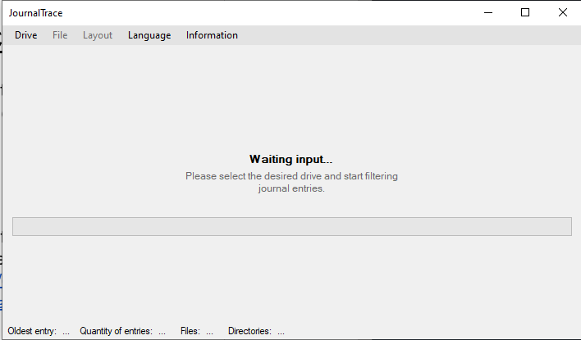
How to use Journal-Trace/EchoJournalTool:
On Journal-Trace after opening the application it should look like this:

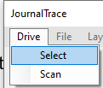
press on “drive” and press “select”

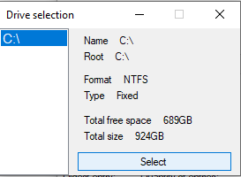
Next select the users main drive (C:\):

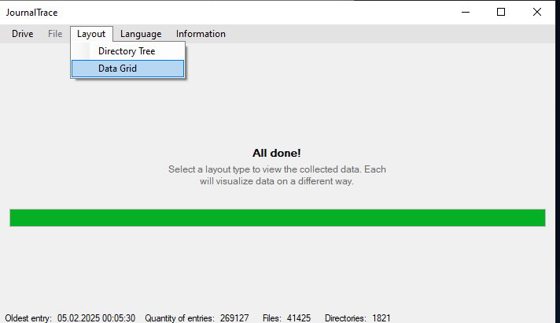
After selecting it press on “drive” again and press “scan”

after scanning press on “Layout” and select “Data Grid”.
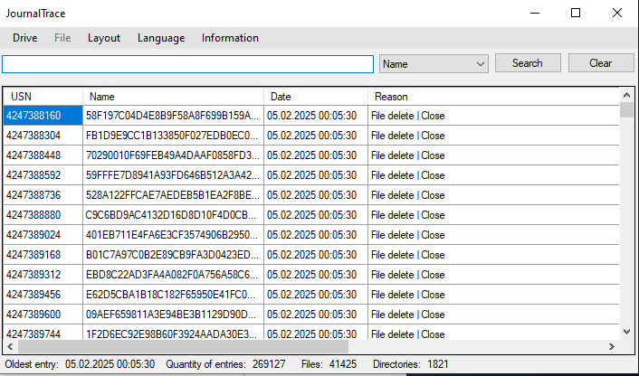

Now here you have the USN Journal entries as example you can see what files the user deleted. Now type in the Search bar .jar and look for any recently deleted mods.

as we can see here lithium-fabric-mc1.21.0.jar got deleted out of the users mods folder. If the timestamp matches before the screenshare ban the user.

Step 2.
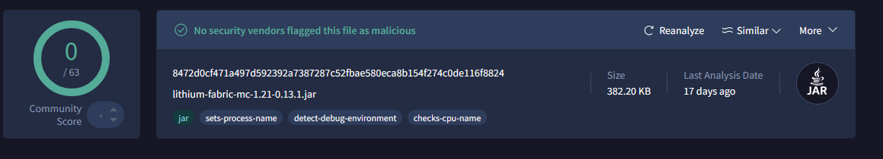
Uploading all mods to virustotal and analyzing them.

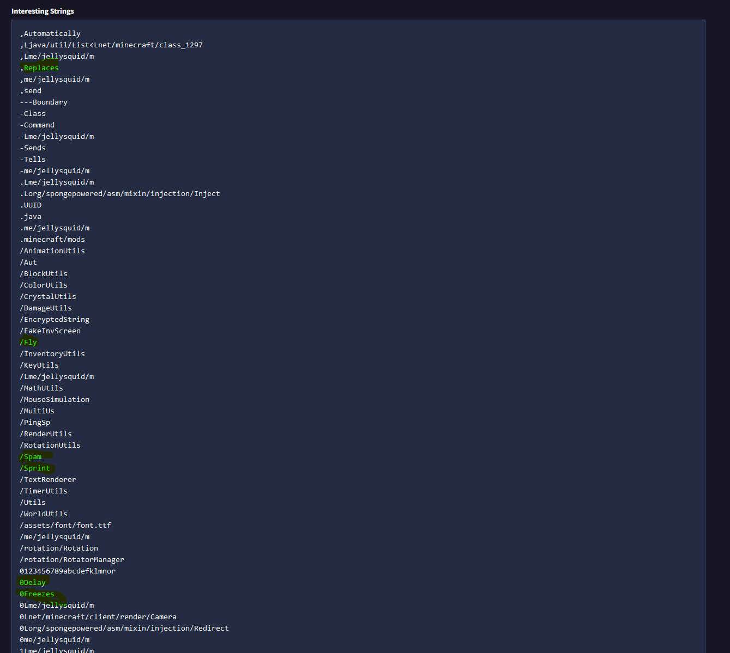
Here i uploaded Nova Client to Virustotal.com and as we can see under “Interesting Strings” there is a lot of stuff that shows us its a cheat:

As you can see here as example /fly or /sprint
I even added a Comment onto Nova Client so its easier to identify.

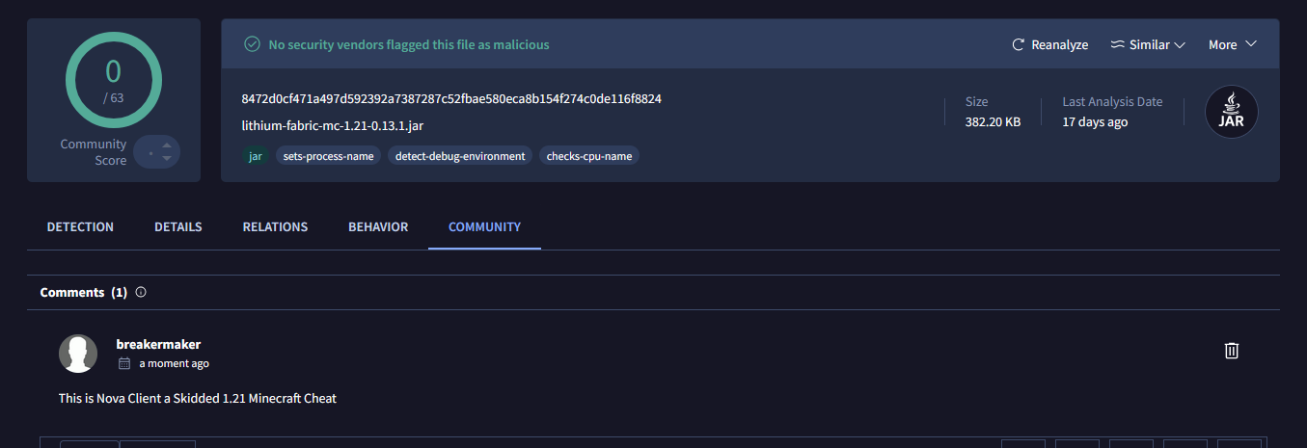

Step 3.
Decompiling all mods manually (If you need a scanner that automates all that Dm me on discord: breakermaker, i have recently made my own Scanner which detects Nova Client with ez)

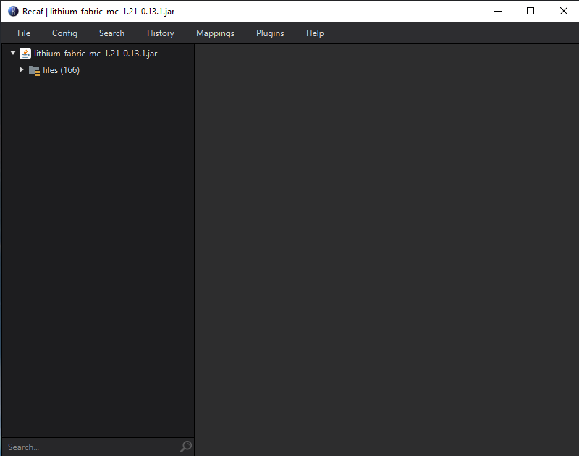
Download a Decompiler like Lyten, ByteCodeViewer, or Recaf. I'll be using Recaf. Open up Recaf and drag the suspicious Mod inside:

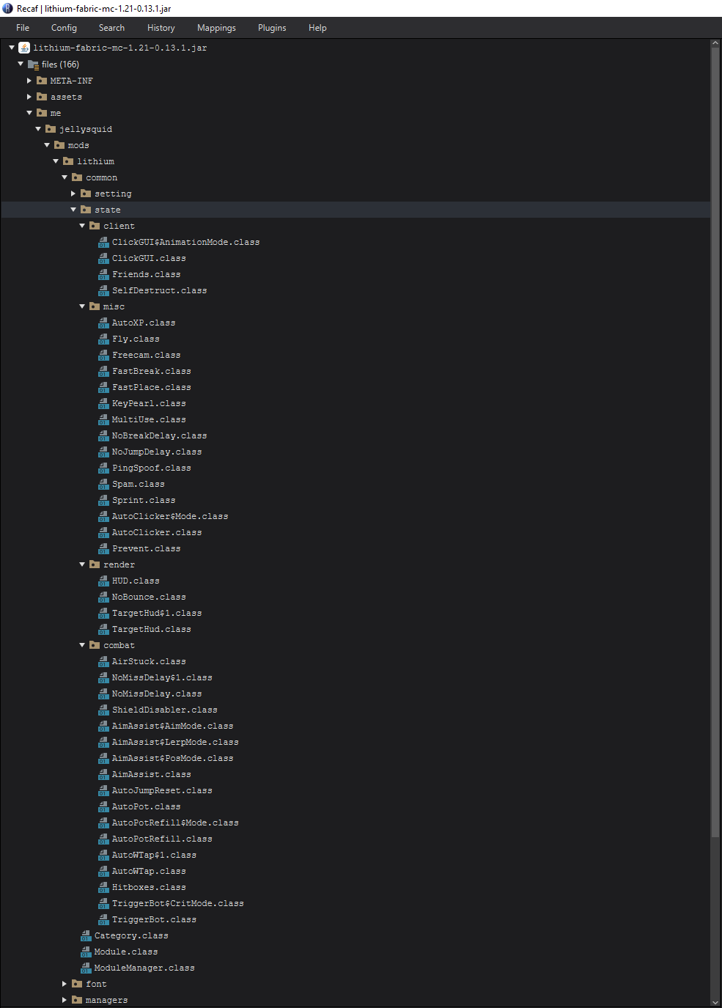
Under: me/jellysquid/mоds/lіthіum/cоmmon/state/ you can see all the modules in the categories Combat, Misc, Client and Render:

Step 4.

Strings…
Personally i wouldn't rely on Strings but since Nova Client is really shit you can surely use strings.
As Example:
“Settings for the client”
“Tm92YSBDbGllbnQ=”
“U2VsZiBEZXN0cnVjdA==”

This is probably outdated, if one of you has the newest Nova Client version just send it to me via Discord: breakermaker i will get new strings and add them here.
I have received the newest nova client version and its still shit…
working strings:
“0123456789abcdefklmnor”
“Tm9CcmVha0RlbGF5”
“Listening…”
“629390927”
“UJHfsGGjbPfVZ”
(outdated)

This is just a small guide on how to find Clients like nova client…

since these niggas be clearing journal now to bypass echo journal heres a guide how to detect usn journal clearance:
**Cleared Usn Journal**

As many people how with this Windows commandline command you can clear the USN Journal to bypass echo journal viewer etc. `fsutil Usn deletejournal /D C:` here i will show yall how to detect this.

**Method 1:**

The eventlog service can save when we delete all USN Journal logs.

1) Run Windows + R = eventvwr.
2) Open Application and select Filter current log.
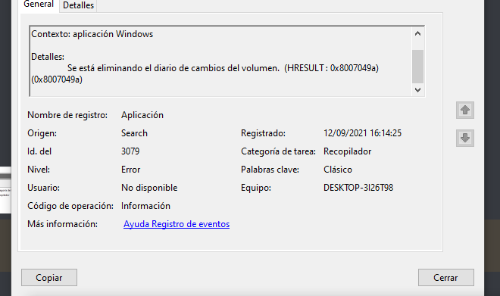
3) Filter by ID: 3079.

